**HW 3 Graph**

1. Draw Picture of the specified graph. Graph G has vertex set { v1,v2,v3,v4,v5} and edge set {e1,e2,e3,e4} with edge-endpoint function as follows:

|  |  |
| --- | --- |
| Edge | Endpoints |
| e1 | {v1,v2} |
| e2 | {v1,v2} |
| e3 | {v2,v3} |
| e4 | {v2} |

e4

V2

e3

e2

e1

V1

V3

1. For this graph

v1

v5

v4

v2

v3

v6

e1

e2

e3

e4

e5

e7

e8

e6

e9

v7

1. Find all edges that are incident on v1 e1,e5,e6 .

1. Find all vertices that are adjacent to v3 V2,V4 .
2. Find all loops e9 .
3. Find all isolated point V7 .
4. Find the degree of v4 4 .
5. Find the total degree of the graph 18 .
6. Construct a precedence graph for the following program:

S1: x:=0

S2: x:=x+1

S3: y:=2

S4: z:=y

S5: x:=x+2

S6: y:=x+z

S7: z:=4

Ans:

x = 3 , y= 5 , z= 4 .

1. For each of the following graphs determine:
2. Whether or not the graph has an Euler Circuit.

No .

1. Whether or not the graph has an Euler Path.

Yes .

1. Whether or not the graph has a Hamilton Circuit.

No .

1. Whether or not the graph has a Hamilton Path.

Yes .

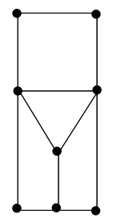

1. Whether or not the graph has an Euler Circuit.

Yes .

1. Whether or not the graph has an Euler Path.

No .

1. Whether or not the graph has a Hamilton Circuit.

No .

1. Whether or not the graph has a Hamilton Path.

Yes .

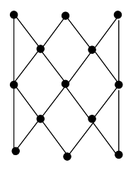

1. For each of the following weighted graphs, use Dijkstra’s Algorithm to find a shortest path from a to z.

Output

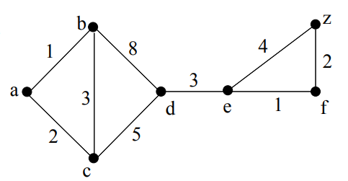

The shortest path has weight: 13 and follows the vertex sequence sequence < a,c,d,e,f,z >.

1. Use a brute force algorithm to find an optimal solution for the **traveling salesman problem** for the given graph starting at “home” vertex a:

|  |  |
| --- | --- |
| Possible Path | Total Weight |
| a,c,d,b,a | 23 |
| a,d,c,b,a | 15 |
| a,b,d,c,a | 23 |
| a,b,c,d,a | 15 |
| a,d,b,c,a | 22 |
| a,c,b,d,a | 22 |
|  |  |
|  |  |

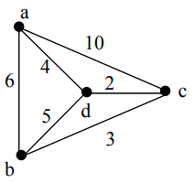

The minimal circuits starting at a are a,d,c,b,a and a,b,c,d,a ,

which both have total weight 15 .

1. **Graph Coloring**. Suppose want to schedule some final exams for CS courses  with following course numbers:  1007, 3137, 3157, 3203, 3261, 4115, 4118, 4156

Suppose also that **there are no students in common taking  the following pairs of** courses:  1007‐3137  1007‐3157, 3137‐3157  1007‐3203  1007‐3261, 3137‐3261, 3203‐3261  1007‐4115, 3137‐4115, 3203‐4115, 3261‐4115  1007‐4118, 3137‐4118  1007‐4156, 3137‐4156, 3157‐4156

How many exam slots are necessary to schedule exams?

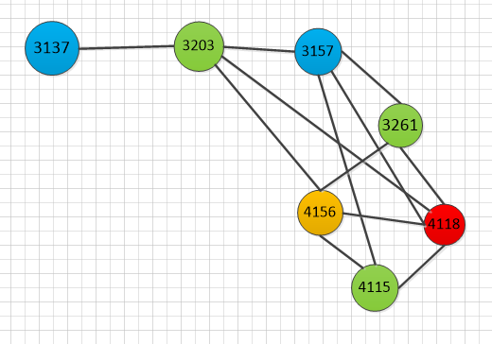

1. An arbitrary number of colors may be  needed if regions are not contiguous.

This example needs 4   color.

